ELECENG 2CJ4
Lab 3 Report
Differentiator and Integrator Circuits

3/5/2025
Jasmine Dosanjh – L03 – dosanj5 – 400531879
Akinniyi Chidiebube – L03 – akinniyc - 400501611

Introduction
The Voltage Integrator is an application circuit of the operational amplifier whose output voltage is the mathematical integration of the input voltage with respect to time. This output result is obtained by placing a capacitor rather than a resistor in the feedback path. It is commonly used in analog-to-digital conversion and in wave shaping (distorting waveforms to increase their complexity).
In the lab, we explored the behaviour of the Voltage Integrator circuit. We observed its operations under different conditions, with an interest in its integrating ability and the effects of time (frequency) on the expected output. This report summarizes the results of the laboratory experiments and the conclusions that we drew from them.

2. Operational Principle of the experiment
We must determine the output voltage of the integrator in Figure 4, using Equation 1:
$$v_{o}\left(t\right)=-\frac{1}{R_{3}C_{3}}\int_{0}^{t}{v_{in}\left(x\right)dx+v_{0}\left(0\right)}→(1)$$
1) When the input voltage is a square wave, the period is
$$\frac{1}{1kHz}=1ms$$
With a pk-pk amplitude of 2V, the area is
$$\int_{0}^{t}{v_{i}\left(x\right)dx}=∆V*∆t=1*\frac{1ms}{2}=0.5mV/s$$
Therefore, plugging in the known values gives:
$$v_{o}\left(t\right)=-\frac{1}{\left(10kΩ\right)\left(100nF\right)}\left(\frac{0.5mV}{s}\right)=-0.5V$$
Therefore, the output wave will be a triangular wave oscillating between -0.5V and 0.
Plotting the relationship between input and output voltage:
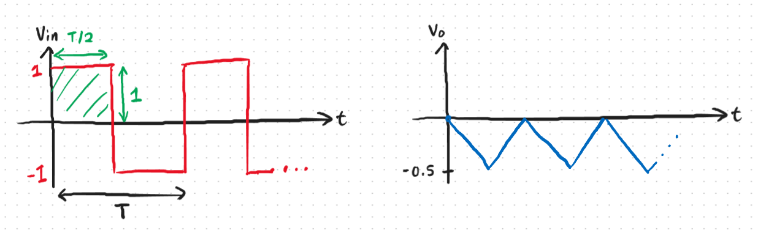
Figure 1. Square wave input vs Triangular output

2) When the input voltage is a sine wave, the output voltage is:
$$v_{o}\left(t\right)=-\frac{1}{\left(10kΩ\right)\left(100nF\right)}\int_{0}^{t}{\sin\left(2π(1000)x\right)}dx=-1000\left(\frac{-cos⁡(2000πt{)}}{2000π}\right)$$
$$v_{o}\left(t\right)=0.159cos⁡(2000πt{)}$$
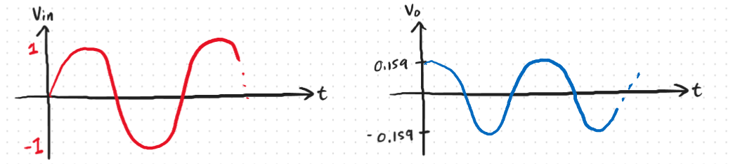
Figure 2. Sine wave input vs Cosine output

3. Measurement results
The AD3 measurement results and their resulting waveforms and circuits are included below.
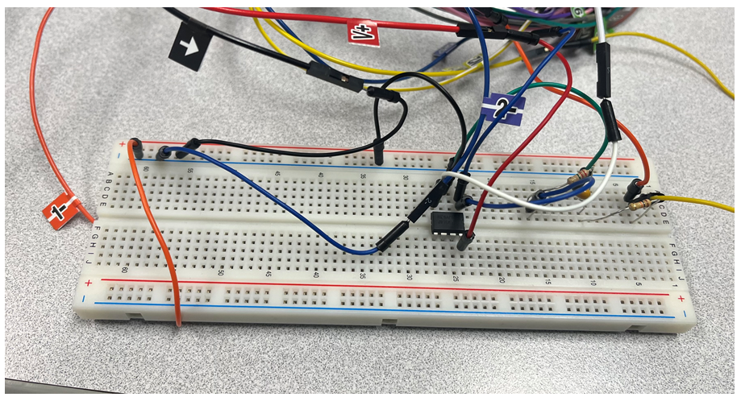
Figure 3. Physical Circuit
- Square wave input
Output is a triangular wave oscillating from -0.023V to -0.569 V.
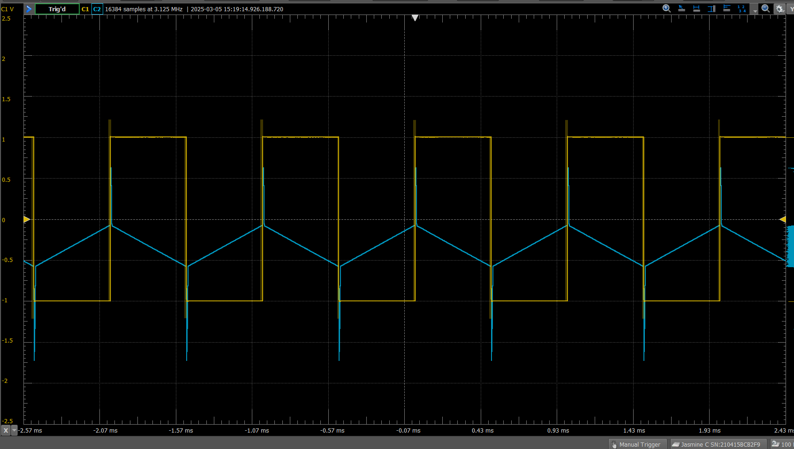
Figure 4. Square wave input Simulation

- Sine wave input
Output is a cosine wave with an amplitude:
$$Amplitude=\frac{V_{max}+V_{min}}{2}=\frac{251.7mV+85.81mV}{2}=168.755mV=0.169V$$
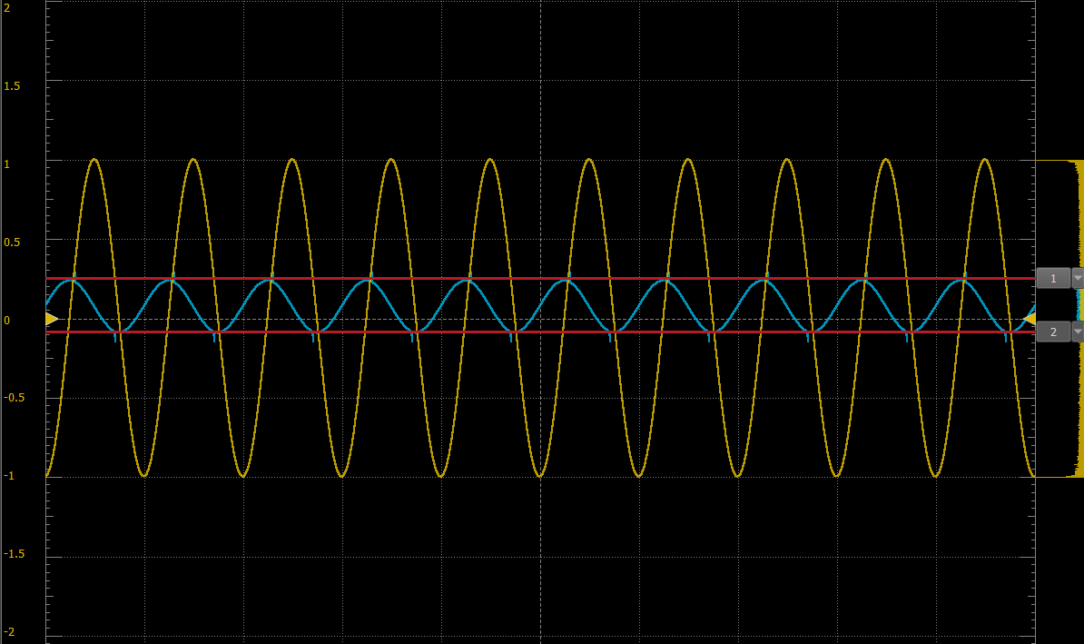
Figure 5. Sine wave input Simulation

4. Discussion
Comparing theoretical Analysis vs Measured responses:
The square wave input was theoretically determined to have a triangular output oscillating from 0V to -0.5V. Using the AD3, it was measured to go oscillate -0.023V to -0.569 V. Secondly, The sine wave input was theoretically determined to have a cosine input oscillating with an amplitude of 0.159V. The measured amplitude was approximately 0.169V. These variations can be due to factors such as noise and component tolerances.

Effect of setting a 10Hz Frequency:
For both the square and sine wave inputs, setting the frequency to 10Hz causes the amplitude of the waveform to increase, thereby increasing the gain of the op-amp. Thus, the output saturates at $\sim V_{CC}$ and $\sim V_{EE}$. Due to factors such as the quality of the op-amp, it does not saturate exactly at ±5V.

- Sine wave input:
For Equation 1, decreasing the input wave frequency causes an increase in the output wave amplitude because the output is proportional to $\frac{1}{f}$. This means that decreasing the frequency increases the output amplitude.
$$v_{o}\left(t\right)=-\frac{1}{R_{3}C_{3}}\int_{0}^{t}{\sin\left(2πfx\right)dx}=-\frac{1}{R_{3}C_{3}}\left(\frac{-cos⁡(2πft{)}}{2πf}\right)$$
$$v_{o}\left(t\right)∝\frac{1}{f}$$
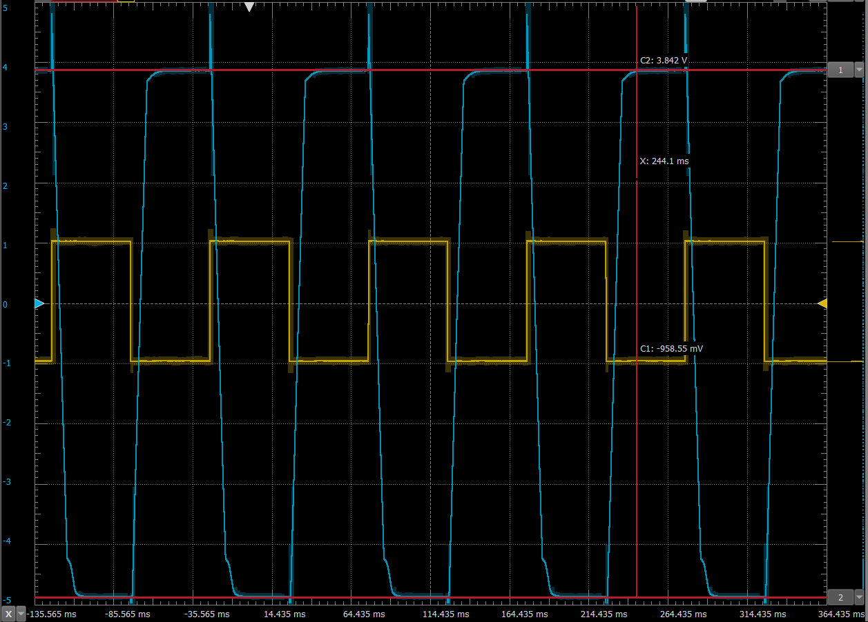
Figure 6. Saturated Triangular output with Square input

- Square wave input:
Similarly,
$$v_{o}\left(t\right)=-\frac{1}{R_{3}C_{3}}\int_{0}^{t}{v_{i}\left(x\right)dx}=-\frac{∆V*∆t}{R_{3}C_{3}}=-\frac{Amplitude*\frac{T}{2}}{R_{3}C_{3}}=-\frac{Amplitude*2}{fR_{3}C_{3}}$$
$$v_{o}\left(t\right)∝\frac{1}{f}$$
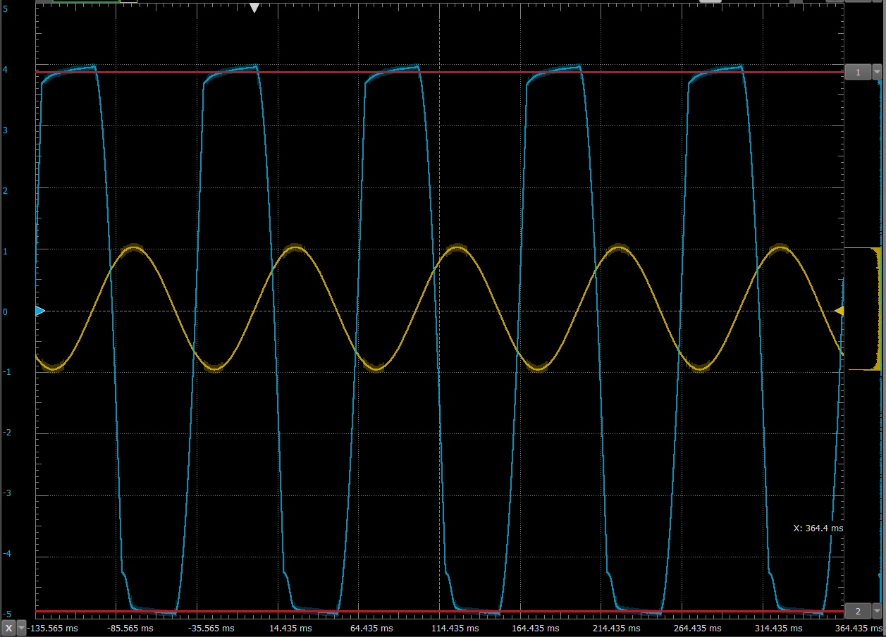
Figure 7. Saturated Cosine output with Sine input

